|  |  |
| --- | --- |
| Date | 06 May 2023 |
| Team ID | NM2023TMID03625 |
| Project Name | Deep Learning Model for Detecting disease in Tea Leaves |

**Problem Statement :**

Detecting disease in tea crop using deep learning concept. Predict the disease using CNN algorithm ( Convolutional neural networks ).

Deep learning area of research to have great potential in terms of increased accuracy . visualization techniques to detect and classify the symptoms of tea leaves disease.

**Keywords:**

Deep learning, disease, convolutional neural networks.

**Introduction:**

The Deep Learning (DL) approach is a subcategory of Machine Learning (ML), introduced in 1943. when threshold logic was introduced to build a computer model closely resembling the biological pathways of humans. This field of research is still evolving; its evolution can be divided into two time periods-from 1943–2006 and from 2012–until now. During the first phase, several developments like back propagation chain rule , hand written text recognition and resolving the training problem were observed However, in the second phase, state-of-the-art algorithms/architectures were developed for many applications including self-driving cars healthcare sector text recognition , earthquake predictions , marketing , finance , and image recognition. A convolutional neural network (CNN) is a type of artificial neural network used primarily for image recognition and processing, due to its ability to recognize patterns in images. A CNN is a powerful tool but requires millions of labelled data points for training. For the implementation of DLmodels,several steps are required, from the collection of datasets visualization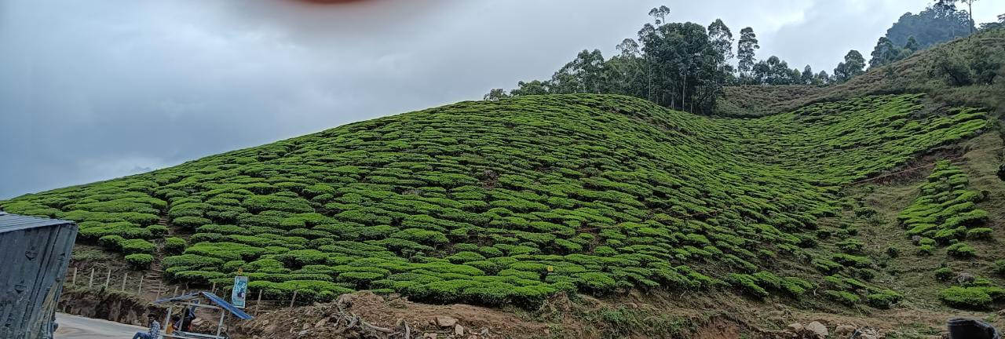

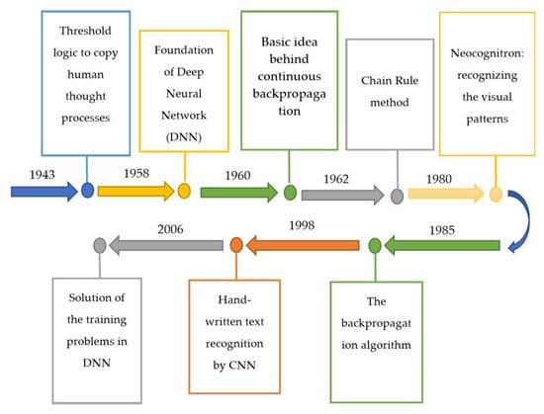 fig.1 Evolution of deep learning from 1943 to 2006

When DL architectures started to evolve with the passage of time, researchers applied them to image recognition and classification. These architectures have also been implemented for different agricultural applications. For example, in classification of leaves was performed by using author-modified CNN and Random Forest (RF) classifier among 32 species in which the performance was evaluated through CA at 97.3%. On the other hand, it was not as efficient at detecting occluded objects . leaf and fruit counting were also performed by deep CNN and respectively.

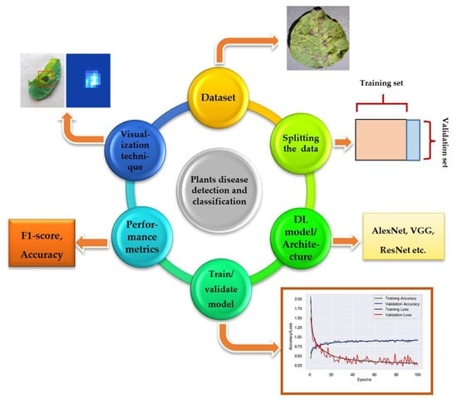

2**. Plant Disease Detection by Well-Known DL Architectures**

Many state-of-the-art DL models/architectures evolved after the introduction of CNN for image detection, segmentation, and classification. This section presents the researches done by using famous DL architectures for the identification and classification of plants’ diseases. Moreover, there are some related works in which new visualization techniques and modified/improved versions of DL architectures were introduced to achieve better results. Among all of them, the Plant Village dataset has been used widely as it contains 54,306 images of crops having 26 plant diseases . Moreover, they used several performance metrics to evaluate the selected DL models, which are described as below.

**Implementation of DL Models**

**1. Without Visualization Technique**

In CNN was used for the classification of diseases in maize plants and histogram techniques to show the significance of the model. basic CNN architectures like AlexNet, GoogLeNet and ResNet were implemented for identifying the tea leaf diseases. Training/validation accuracy were plotted to show the performance of the model; ResNet was considered as the best among all the CNN architectures. In order to detect the diseases in tea leaf, LeNet architecture was implemented and CA, F1-score were used for the evaluation of the model in Color and Gray Scale modes . Five CNN architectures were used in namely, AlexNet, AlexNetOWTbn, GoogLeNet, Overfeat, and VGG architectures in which VGG outclassed all the other models. Support Vector Machines (SVM), Extreme Learning Machine (ELM), and K-Nearest Neighbor (KNN)), used with the state-of-the-art DL models like GoogLeNet, ResNet-50, ResNet-101, Inception-v3, InceptionResNetv2, and SqueezeNet. A comparison was made between those models, and ResNet-50 with SVM classifier got the best results in terms of performance metrics like sensitivity, specificity, and F1-score. According to a new DL model—Inception-v3—was used for the detection of cassava disease. In plant diseases in cucumber were classified by the two basic versions of CNN and got the highest accuracy, equal to 0.823. The traditional plant disease recognition and classification method was replaced by Super-Resolution Convolutional Neural Network (SRCNN) in [61]. For the classification of tea plant disease, AlexNet and SqueezeNet v1.1 models were used in which AlexNet was found to be the better DL model in terms of accuracy . A comparative analysis was presented in to select the best DL architecture for detection of plant diseases No visualization technique was applied to spot the symptoms of diseases in the plants.

**Types of disease affected in tea:**

Blister blight.

Red rust.

Brown blight, grey blight.

Twig die back, stem canker.

Brown root rot disease.

Red root rot disease.

Disease cycle.

IPM for Tea. 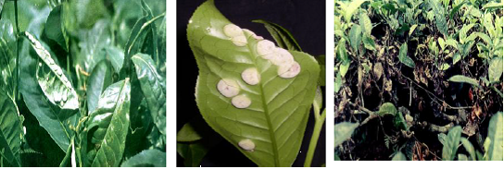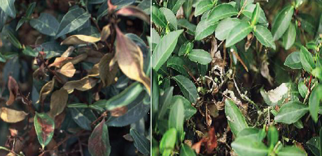

**Symptoms:**

1.Leaves develop lesions that are roughly circular, raised, and purple to reddish-brown. The alga may spread from leaves to branches and fruit.

2.Most algal spots develop on the upper leaf surface.

3.Older infections become greenish-gray and look like lichen. Cephaleuros usually does not harm the plant.

**1.Bounding box indicates the type of diseases**

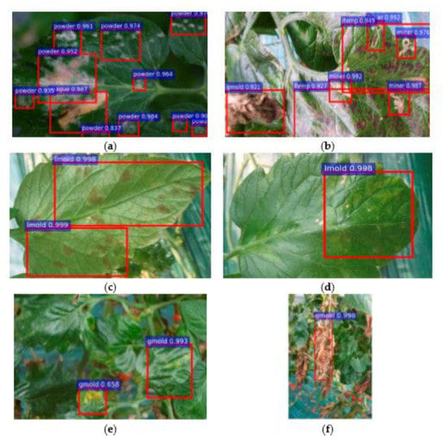

**2.Architecture approach and segmentation:**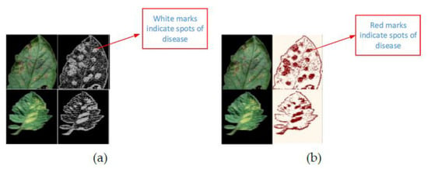

**3.Approach visualization map with the previous approaches:**

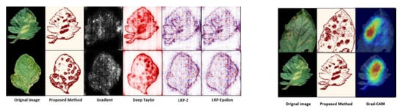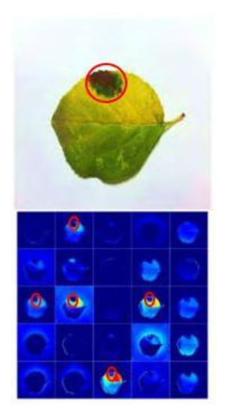**fig.** **Activation visualization for detection of plant disease to show the significance of a VGG the plant disease**

**is indicated by the red circle.**

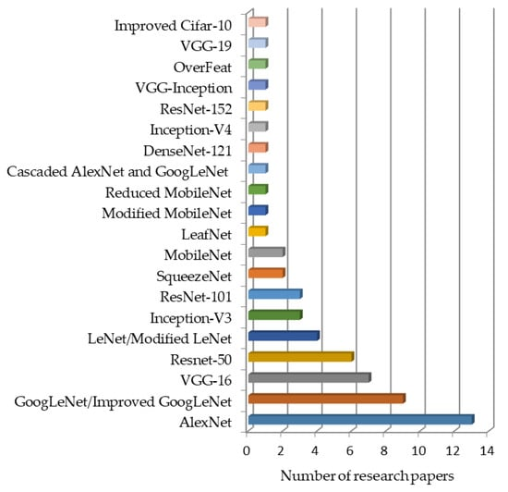

Fig. . Deep learning models used in the particular number of research papers.

How is CNN used in plant disease detection?

Deep Convolutional Neural Network is utilized in this study to identify infected and healthy leaves, as well as to detect illness in afflicted plants. The CNN model is designed to suit both healthy and sick leaves; photos are used to train the model, and the output is determined by the input leaf. 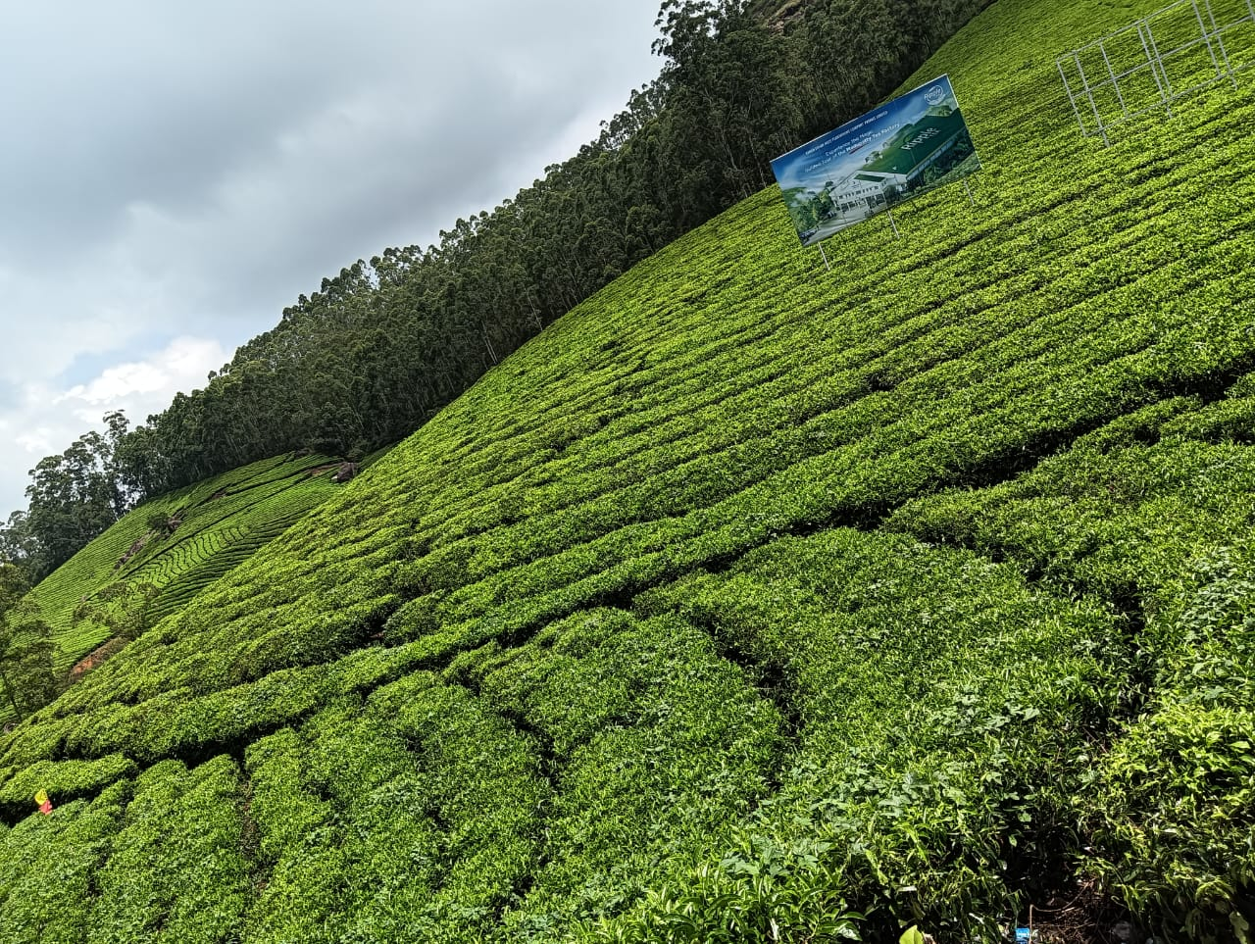

Tea leaf diseases caused by persistent pathogen exposure result in considerable crop yield losses around the world. Detection of the disease of tea leaves at early stages can reduce the damage of tea output. Detecting the disease with the naked eye can be inefficient and counterproductive. Convolutional Neural Networks (CNNs) are commonly used to implement an effective method for the image classification. In detection of plant disease, the use of CNN is widespread. Therefore, in the proposed work, a Deep CNN having multiple hidden layers is considered for the classification of diseased tea leaves into different categories. This helps the network in detecting more number of features and thereby improving the accuracy in disease detection. The classification is done consisting of the following categories of leaves; Gray Blight, Algal Spot, Brown Blight, Helopeltis, Healthy Leaves and Red Spot. Further, a labeled dataset consisting of 5867 diseased and healthy tea leaf images have been created and uploaded on Kaggle. The suggested method demonstrates that the model is able to accurately detect the kind of persistent tea leaf disease with a 96.56% accuracy. The accuracy of the following disease classes are as follows, Algal Spot has an accuracy of 98.23%, Brown Blight has an accuracy of 97.98%, Gray Blight has an accuracy of 93.46%, Healthy classes of leaves has an accuracy of 99.10%, the Helopeltis disease class has an accuracy of 98.98% and Red Spot has an accuracy of 92% The model that is proposed in this literature is far superior than the existing methods in terms of accuracy.